**CS550 Advanced Operating Systems**​

**Programming Assignment 3**

​

**Evaluation**

**Experiment-2**

**Amazon Aws**

**submitted by:**

Chiranjeevi Ankamreddy

A20359837

The assignment carries out Evaluation of the Decentralized Indexing server and Peer server on 1000 operations run on Amazon aws..

I’ve evaluated the time taken to **Register ,Search** operations on a Indexing server a single node ,two nodes ,four nodes and eight running concurrently over **1000** operations.

And Evaluated the time taken to **Obtain** Files on a Peer server a single node ,two nodes ,four nodes and eight running concurrently over 1000 operations. And File Size is **1MB.**

**1. Register:**

***single node:*** ​The time taken to Register 1000 Files on a single node at is 2440**millisecs**​.

Two  ***nodes :*** ​ The time taken to Register 1000 Files on each of 2 nodes is :

node 1 ­ 2980 millisecs

node 2 ­ 3246millisecs

Average time taken by a node to Register 1000 Files is : 2980+3246/2

=​ **3113 millisecs**

***Four nodes :*** ​ The time taken to Register 1000 Files on each of four nodes is :

node 1 ­ 3085 millisecs

node 2 ­ 3487 millisecs

node 3- 4129millisecs

node 4- 4573millisecs

Average time taken by a node to Register 1000 Files is:3085+3487+4129+4573/4=  **3818.5millisecs**

***Eight nodes :*** ​ The time taken to Register 1000 Files on each of Eight nodes is :

node 1 ­ 3587millisecs

node 2 ­ 4298millisecs

node 3- 4961 millisecs

node 4 ­ 4726.2millisecs

node 5 ­ 5188 millisecs

node 6- 4487millisecs

node 7 ­ 5347millisecs

node 8 ­ 6189 millisecs

Average time taken by a node to Register 1000 Files is:  **4073.8millisecs**

**Average time taken for a single node per Register 1000 Files : 2440 millisecs**

**Average time taken for two concurrent nodes per Register 1000 Files : 3113 millisecs**

**Average time taken for four concurrent nodes per Register 1000 Files : 3818.5millisecs**

**Average time taken for a eight concurrent nodes per Register 1000 Files : 4073 millisecs**

**PLOT FOR REGISTER :**

**X­axis : nodes**

**Y­Axis : time (millisecs)**

C:\Users\Chiru\Downloads\Untitled Diagram (1).png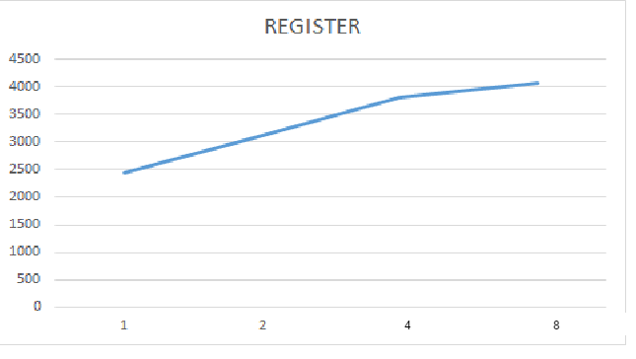

C:\Users\Chiru\Downloads\Untitled Diagram.png

**2. SEARCH :**

***single node:*** ​The time taken to Search 1000 Files on a single node at is 3124**millisecs**​.

Two  ***nodes :*** ​ time taken to Search 1000 Files on each of 2 nodes is :

node 1 ­ 3321 millisecs

node 2 ­ 3547 millisecs

Average time taken by a node to Search 1000 Files is : 3436 **millisecs**

***Four nodes :*** ​Time taken to Search 1000 Files on each of four nodes is :

node 1 ­3654 millisecs

node 2 -3971 millisecs

node 3- 3579 millisecs

node 4- 4217millisecs

Average time taken by a node to make Search 1000 Files is 3855.5  **millisecs**

***Eight nodes :*** ​Time taken to Search 1000 Files on each of Eight nodes is :

node 1 ­ 3874millisecs

node 2 ­4125 millisecs

node 3- 4474 millisecs

node 4 ­ 4725 millisecs

node 5 ­ 5114 millisecs

node 6- 5498millisecs

node 7 ­ 5247millisecs

node 8 ­ 5007 millisecs

Average time taken by a node to Search 1000 Files is  **4758 millisecs**

**Average time taken for a single nodes per 1000 Search Files : 3124 millisecs**

**Average time taken for two concurrent nodes per 1000 Search Files : 3436 millisecs**

**Average time taken for four concurrent nodes per 1000 Search Files : 3855.5 millisecs**

**Average time taken for a eight concurrent nodes per 1000 Search Files : 4758 millisecs**

**PLOT FOR SEARCH:**

**X­axis : nodes**

**Y­axis : time (millisecs)**

**C:\Users\Chiru\Downloads\Untitled Diagram (1).png**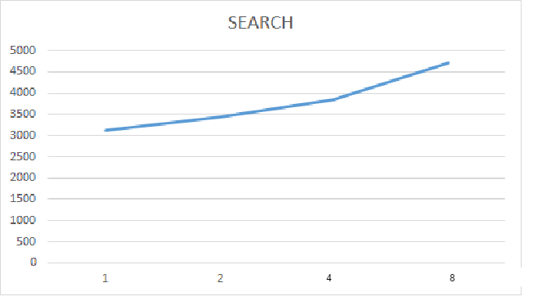

C:\Users\Chiru\Downloads\Untitled Diagram.png

**3. Obtain:**

***single node:*** ​The time taken to obtain 1000 Files at a single node at is ​ **198 secs**.​

***two nodes :*** ​ Time taken to obtain 1000 Files at 2 nodes concurrently

node 1 ­ 194secs

node 2 ­ 226secs

Average time taken by a node to obtain 1000 Files is=​**210secs**

***Four nodes :*** ​Time taken to obtain 1000 Files on each of four nodes is :

node 1 ­ 217secs

node 2 ­ 234secs

node 3- 257secs

node 4- 248secs

Average time taken by a node to obtain 1000 Files is : 239 **secs**

***Eight nodes :*** ​Time taken to obtain 1000 Files on each of Eight nodes is :

node 1 ­ 267 secs

node 2 ­ 254secs

node 3- 287secs

node 4 ­ 311secs

node 5 ­ 339secs

node 6- 298secs

node 7 ­ 357secs

node 8 ­ 385secs

Average time taken by a node to obtain 1000 Files is /8= 311 **secs**

**Average time taken for a single node to obtain 1000 Files : 198 secs**

**Average time taken for two concurrent nodes to obtain 1000 Files : 210 secs**

**Average time taken for four concurrent nodes to obtain 1000 Files :239 secs**

**Average time taken for a eight concurrent nodes to obtain 1000 Files: 311secs**

**PLOT FOR OBTAIN:**

**X­axis : nodes**

**Y­axis : time(secs)**

**C:\Users\Chiru\Downloads\Untitled Diagram (1).png**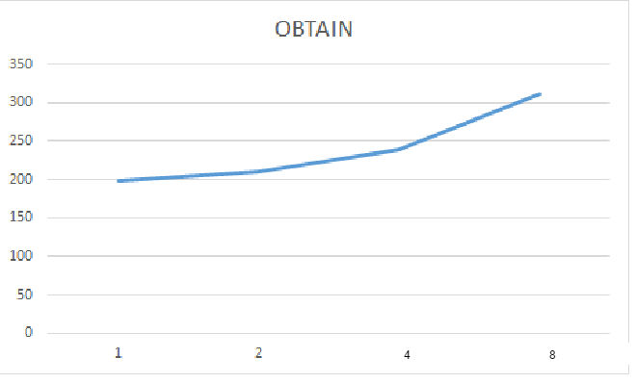

**Conclusion:**

Here,we have evaluated register,search and obtain the files of size 1Mb.and it runs on Amazon aws cloud over 1000 fileS on each server.As the number of nodes increases,time to register will increases in DIS, and search is increases initially because IN DHT, it runs on core uses maximum speed. And obtaining file is also uses maximum core speed.

C:\Users\Chiru\Downloads\Untitled Diagram.png